National College of Computer Studies
(NCCS-College of IT & Management)
Paknajol, Kathmandu


Report on
“Login and Registration System”

Submitted by: Submitted to:
Sudesh Godar Janak sir
BSc.CSIT 2nd semester
Roll No.:22

Acknowledgement
I would like to express my sincere gratitude to NCCS College for providing the necessary facilities and support for the successful completion of this project.
Special thanks to Mr. Janak Joshi sir for his invaluable guidance, mentorship, and continuous support throughout the duration of this project on the topic of "Login and Registration System." His expertise and encouragement were instrumental in shaping the direction and execution of this work.
I am also grateful to all the individuals who contributed directly or indirectly to this project, offering their insights, feedback, and assistance.
Thank you all for your unwavering support and encouragement

Sudesh Godar

Abstract
This C++ program represents the basic console-based authentication system that provides the option for login, registration, password retrieval and exiting program. User should first register into the page with their desired username and password and can login anytime using the username and password. It uses different function prototypes such as login (), registration (), forgot password (), exit (). The lo gin() function asks the username to enter the username and password and check if that is correct or not by reading form a file records.txt. The register function allows the user name to register the user name and password and stores in the file records.txt. The forgot password helps to find the password by entering the username of the user and provides the password. The last function is used to exit the program.

Table of Contents
1. Introduction. 1
2. Objectives 2
3. Methodology 3
4. Source Code 5
5. Output: 8
6. Conclusion 9

Introduction
This C++ program presents a simple login system with functionalities for user login, registration, password retrieval, and program exit. We have used file records.txt to store the information provided by the user. This program allows the user to login the page using existing username and password. Also allows the user to create username and password and provides the password if forgot. This C++ program presents a simple login system with functionalities for user login, registration, password retrieval, and program exit.

Objectives
The main objectives of the program are given below:
- Login Functionality: Allows users to input a username and password, then checks this information against records stored in a file (records.txt). If the entered credentials match any existing records, the program displays a success message; otherwise, it prompts for re-entering correct credentials.
- Registration Functionality: Enables users to create new accounts by providing a username and password. It appends this new information to the existing records stored in the records.txt file.
- Forgot Password Functionality: Provides options to retrieve a forgotten password. It allows users to search for their account by providing a username. If the account is found in the records, it displays the corresponding password; otherwise, it informs the user that the account doesn't exist.
- Menu and Program Control: Displays a menu with options for Login, Registration, Forgot Password, and Exit. It uses a switch-case structure to navigate between different functionalities based on user input. Upon completing an action (like login, registration, or password recovery), it returns to the main menu for further a

Methodology
- Menu Display and User Input:
    - Upon execution, the program displays a menu presenting different options to the user.
    - It prompts the user to input a choice corresponding to login, registration, password recovery, or program exit.
- Functionality Execution:
Based on the user's input, the program calls different functions to execute the desired functionality:
    - login(): Validates user-entered credentials against stored records in the file.
    - registration(): Allows users to create new accounts and stores them in the file.
    - forgotpassword(): Provides options for password recovery by searching for the username.
    - exit_program(): Terminates the program gracefully with a goodbye message.
- Login Function (void login()):
  - Collects user input for username and password.
  - Reads the contents of the records.txt file to verify the entered credentials.
  - Notifies the user about successful or failed login attempts.
- Registration Function (void registration()):
  - Accepts user input for a new username and password.
  - Appends the new user details to the records.txt file, allowing for registration.
- Password Recovery Function (void forgotpassword()):
  - Offers users the choice to search for their password by providing the username.
  - Searches the records.txt file for the associated password if the username matches.
- File Handling:
  - Utilizes file streams (if stream and of stream) to interact with the records.txt file.
  - Data is stored in a simple space-separated format: username password.

Source Code
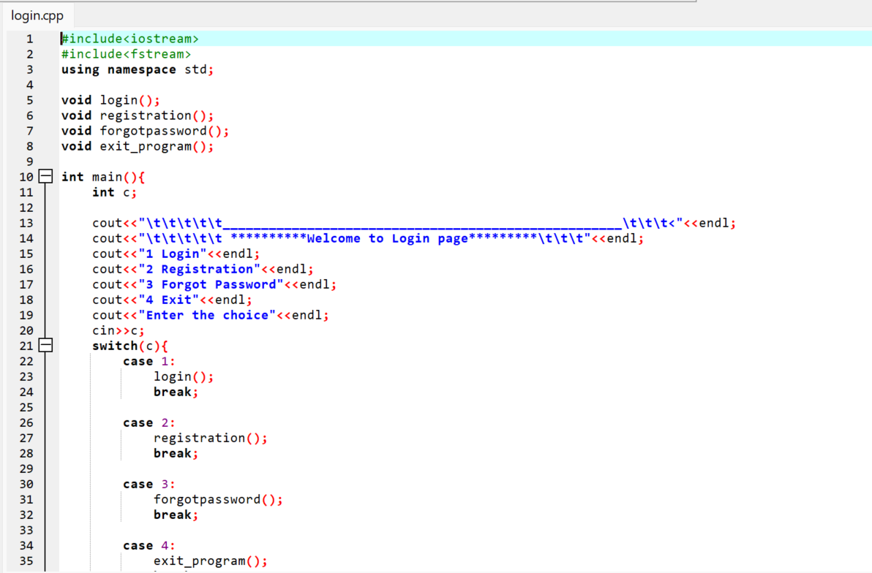
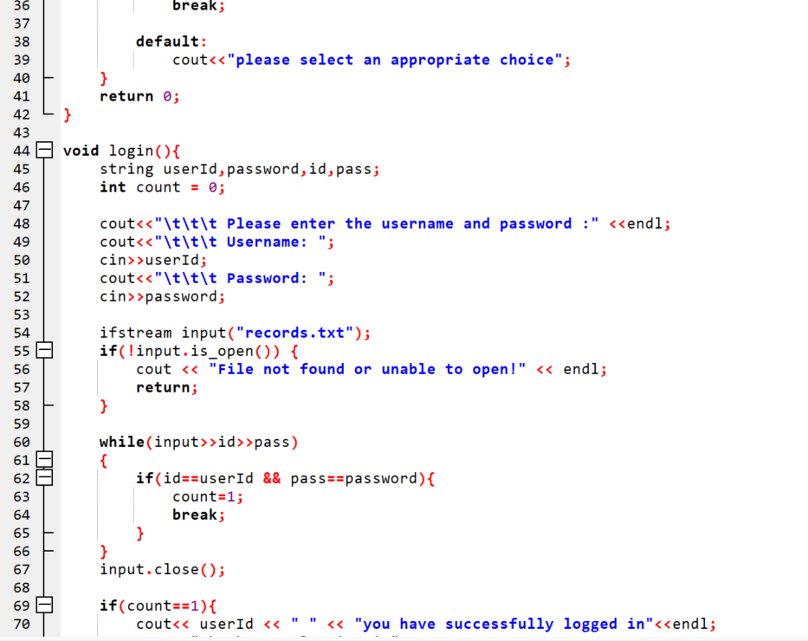
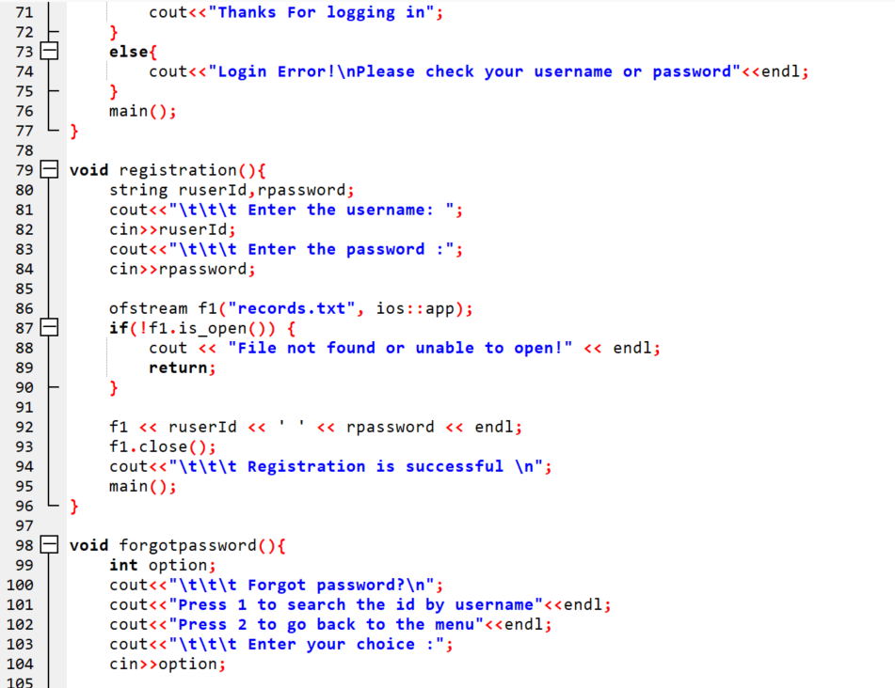
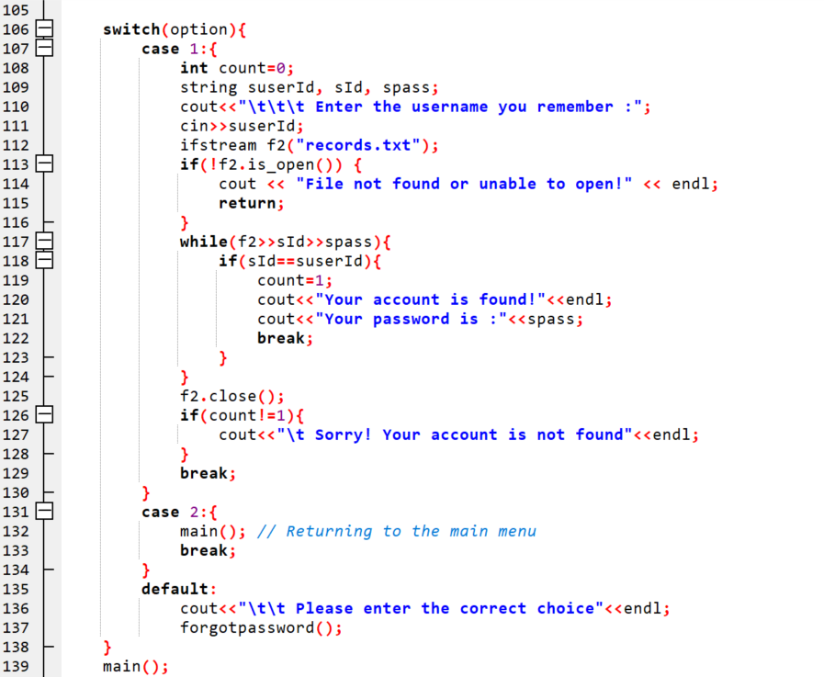
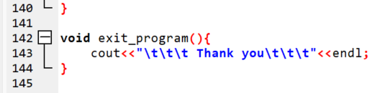

Output:

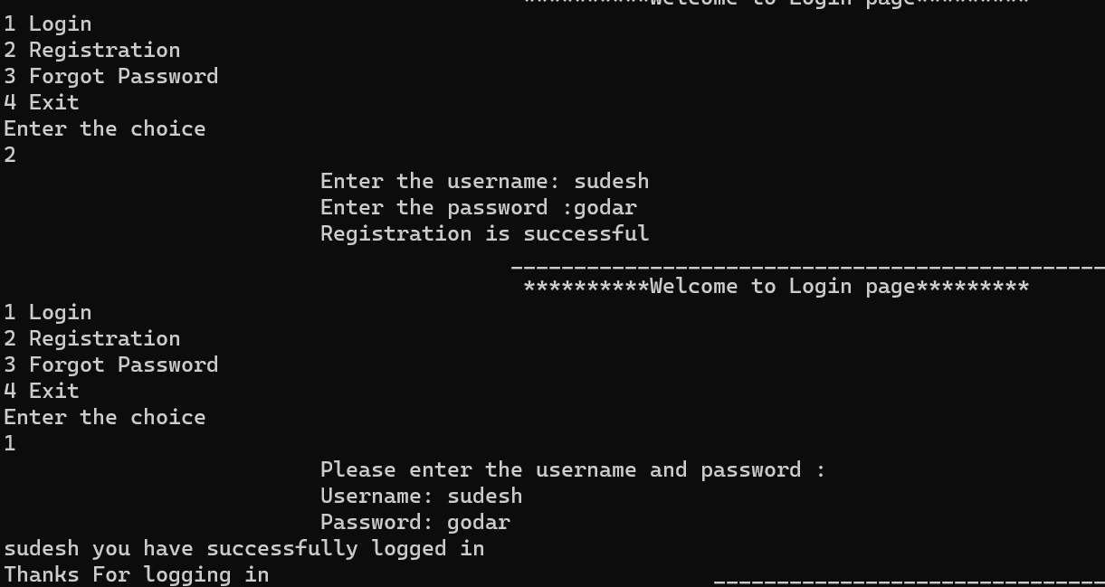

Conclusion

